Notes – Migrate React Project to GitHub

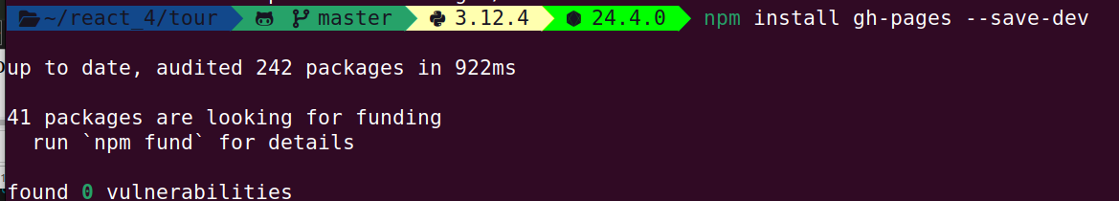

npm install gh-pages --save-dev

added 44 packages, and audited 242 packages in 2s

41 packages are looking for funding
run `npm fund` for details

found 0 vulnerabilities

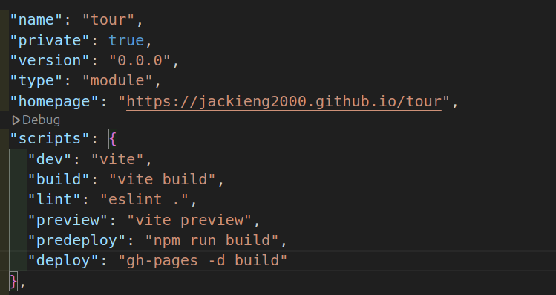
go to package .json

